**INFORMATION ABOUT BABIES**

**FOOD**

**Feeding your baby: 6–8 months old**

* From 6–8 months old, feed your baby half a cup of soft food two to three times a day.
* Your baby can eat anything except honey, which she shouldn't eat until she is a year old.
* You can start to add a healthy snack, like mashed fruit, between meals
* . As your baby gets increasing amounts of solid foods, she should continue to get the same amount of breastmilk.

**Feeding your baby: 9–11 months old**

* From 9–11 months old, your baby can take half a cup of food three to four times a day, plus a healthy snack.
* Now you can start to chop up soft food into small pieces instead of mashing it.
* Your baby may even start to eat food herself with her fingers. Continue to breastfeed whenever your baby is hungry.

**Feeding non-breastfed babies**

* If you are not breastfeeding your baby, she will need to eat more often. She will also need to rely on other foods, including milk products, to get all the nutrition her body needs.
* Start to give your baby solid foods at 6 months of age, just as a breastfed baby would need. Begin with two to three spoonsful of soft and mashed food four times a day, which will give her the nutrients she needs without breastmilk.
* From 6–8 months old, she will need half a cup of soft food four times a day, plus a healthy snack.
* From 9–11 months old, she will need half a cup of food four to five times a day, plus two healthy snacks.

**SLEEP**

* Generally, newborns sleep about 8 to 9 hours in the daytime and about 8 hours at night. But they may not sleep more than 1 to 2 hours at a time. Most babies do not start sleeping through the night (6 to 8 hours) without waking until they are about 3 months old, or until they weigh 12 to 13 pounds. About two-thirds of babies can sleep through the night on a regular basis by age 6 months.

Babies also have different sleep cycles than adults. Babies spend much less time in rapid eye movement (REM) sleep (which is dream time sleep). And the cycles are shorter. The following are the usual nighttime and daytime sleep needs for newborns through 2 years old:

|  |  |  |  |
| --- | --- | --- | --- |
| **Age** | **Total sleep hours** | **Total hours of nighttime sleep** | **Total hours of daytime sleep** |
| **Newborn** | 16 hours | 8 to 9 | 8 |
| **1 month** | 15.5 hours | 8 to 9 | 7 |
| **3 months** | 15 hours | 9 to 10 | 4 to 5 |
| **6 months** | 14 hours | 10 | 4 |
| **9 months** | 14 hours | 11 | 3 |
| **1 year** | 14 hours | 11 | 3 |
| **1.5 years** | 13.5 hours | 11 | 2.5 |
| **2 years** | 13 hours | 11 | 2 |

**VACCINATION**

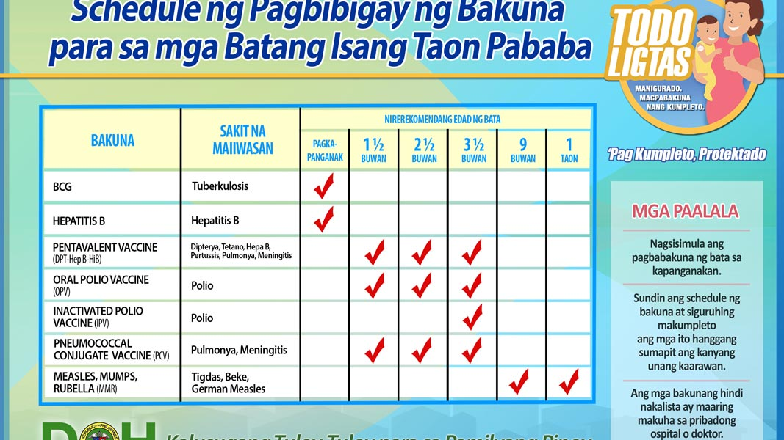

**REFERENCES:**

<https://www.unicef.org/parenting/food-nutrition/feeding-your-baby-6-12-months#:~:text=In%20addition%20to%20grains%20and%20potatoes%2C%20be%20sure%20your%20baby,all%20the%20nutrients%20he%20needs>.

https://www.stanfordchildrens.org/en/topic/default?id=infant-sleep-90-P02237#:~:text=Generally%2C%20newborns%20sleep%20about%208,weigh%2012%20to%2013%20pounds.